## **Chaos Theory and Chaos Map Theme Song**

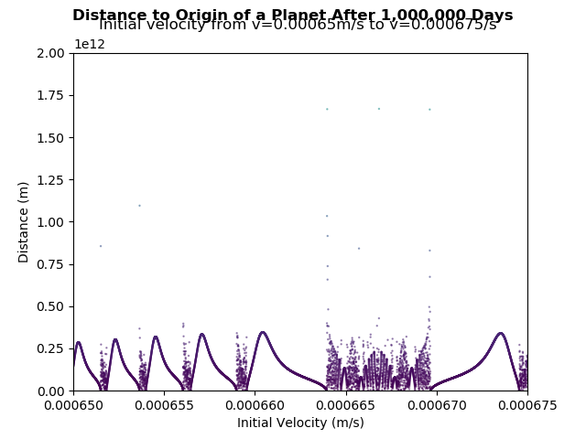

Chaos theory is the study that concerns the predictability of a system. It destroys the intuition that everything would be predictable if the initial conditions are known. The characteristics of a chaotic system were proposed by Robert L. Devaney as follow:

1. it must be sensitive to initial conditions,

2. it must be topologically transitive,

3. it must have dense periodic orbits ("Chaos Theory," n.d., p. 1).

A more concise definition of chaotic systems is a system that can only be described as a system of interrelated differential equations ("Chaos1," n.d.). There are some characteristics of a chaotic system. A chaotic system must be sensitive to initial conditions, which means that a small change of the initial conditions of the system would result in a large change to the final condition we observe. Chaotic systems have unstable periodic properties, meaning that the conditions of the system will roughly repeat itself. However, since it does not meet the exact location and repeat with an exact period, the system results in a dense periodic orbit. The attractor in the center of the trajectories of a chaotic system is also unstable, making itself a strange attractor ("Attractor," n.d., p. 1). A strange attractor has a fractal structure in which infinitely many details can be seen when the logistic graph is zoomed in ("Fractal," n.d., p. 1).

Famous examples of chaotic systems include double pendulums, the Lorenz Attractor, and the n-body problem. One special case of the chaotic systems is the three-body problem (also a special case of an n-body problem). Given the complexity of the force equations involved in a three-body system, it is unrealistic to solve the location of each planet after some time t given all the initial conditions because there is no closed-form solution for this problem ("Three-body Problem," n.d., p. 1). Therefore, a computational simulation of a three-body system and the music generated based on the logistic map would be helpful for understanding the physics of chaos theory in the n-body system.

This project creates logistic maps using the gravitational physics engine. After plotting the distance of the planet to its origin as a function of initial velocity, the graph shows that the system has repetitions, dense periodic orbits, fractal structure, and sensitivity to initial conditions. Firstly, the distance between the final and the original position of the planet oscillates repetitively. Secondly, as the graph zooms in, there are more details in the range selected, but randomly plotted dense dots under or between the periodic trends can still exist, creating densely plotted regions. Thirdly, a relatively small change to its initial velocity can result in a sudden jump in the final position from 0m to 1.75x10^12m at initial condition around 0.000664 to the origin. These pattern observed on a three-body system are in line with the chaos theory.

The theme song relates the patterns on the logistic map to people’s auditory system, creating an intuitive way to interpret chaos theory. The theme song starts with regular repetitive beats. This shows that there are still some predictable patterns in some region of a chaotic system. The song soon build-up to the region of chaos. In the region of chaos, the pitches of the nodes jump suddenly, creating no observable patterns. These random nodes represent the densely plotted region on the logistic map, creating shapes rather than lines. And finally, the song fades out after passing through the region where the mixing of regular and chaotic patterns can be observed.

References

Attractor. (n.d.). In *Wikipedia*. Retrieved May 30, 2019, from https://en.wikipedia.org/wiki/Attractor

Chaos1. (n.d.). Retrieved May 23, 2019, from Chaos Math website: http://www.chaos-math.org/en/film

Chaos Theory. (n.d.). In *Wikipedia*. Retrieved May 23, 2019, from https://en.wikipedia.org/wiki/Chaos_theory

Entertain Me Now 1. (n.d.). *Chaos Theory PBS* [Video file]. Retrieved from https://www.youtube.com/watch?v=FEC_mogwzL8

Fractal. (n.d.). In *Wikipedia*. Retrieved May 30, 2019, from https://en.wikipedia.org/wiki/Fractal

Three-body problem. (n.d.). In *Wikipedia*. Retrieved May 23, 2019, from https://en.wikipedia.org/wiki/Three-body_problem

我们这个反馈的世界 [Our Feedback World]. (n.d.). Retrieved May 23, 2019, from https://zhuanlan.zhihu.com/p/28573752